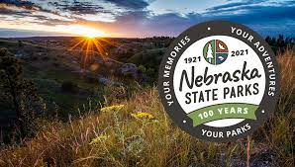
ENDERS FIRST ANNUAL TRAIL RIDE
SEPTEMBER 11, 2021
9:00 AM LUNCH AFTER TRAIL RIDE
LOCATION: NO NAME BAY
PLEASE RSVP BY CALLING OR TEXTING: DAYNA AT 308-233-1026 OR Beau Licking 308-530-2648 so we can get a head count for food.
A park pass is required, can be purchased that day: a yearly or a daily at the park.

